Offline 2 (Linear Regression)

**Problem Statement**

You are given two separate train and test files. Compute the mean squared error of your result.

**Coding Steps**

1. Let your line be:

1. From the training file, compute (β1 and β0) using the following formula:

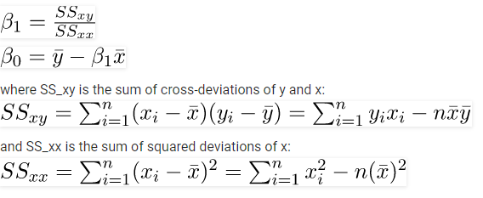

where n = length of training dataset

1. For each input row in the test dataset, compute the difference between your output and given output (εi)
2. Compute mean squared error from the following formula and print your result.



where n = length of test dataset